Coding Challenge 2_RDBMS-CareerHub

mysql> create database company;

Query OK, 1 row affected (0.01 sec)

mysql> use company;

Database changed

mysql> create table companies(

-> companyID int primary key,

-> compamyName varchar(225),

-> location Varchar(225));

Query OK, 0 rows affected (0.05 sec)

mysql> create table jobs(

-> jobID int primary key,

-> companyID int,

-> jobTitle varchar(255),

-> jobDesc text,

-> jobLocation varchar(255),

-> sal decimal(10,3),

-> jobType varchar(255),

-> postedDate DATETIME,

-> FOREIGN KEY (companyID) REFERENCES companies(companyID));

Query OK, 0 rows affected (0.08 sec)

mysql> create table applicants(

-> applicantID int primary key,

-> firstName VARCHAR(255),

-> lastName VARCHAR(255),

-> email varchar(255),

-> phone int,

-> resume text);

Query OK, 0 rows affected (0.04 sec)

mysql> create table applications (

-> aplicationID int primary key,

-> jobID int,

-> aplicantID int

->applicationdate DATRTIME,

->coverLetter text,

-> DATFOREIGN KEY (jobID) REFERENCES jobs(jobID),

->FOREIGN KEY (applicantID) REFERENCES applicants(applicantID));

Query OK, 0 rows affected (0.04 sec)

Insert into companies (CompanyID, CompamyName, Location) VALUES

(1, 'ABC ',’new york’),

(2, 'XYZ’, ‘chennai’),

(3, 'Tech’, ‘chennai’),

(4, 'Global’, 'tokyo'),

(5, ‘pqr’, ‘london’);

INSERT INTO Jobs (JobID, CompanyID, JobTitle, JobDescription, JobLocation, Salary, JobType, PostedDate) VALUES

(1, 1, 'software', 'Develop', 'new york', 300.200, 'full', '2024-01-15’),

(2, 2, 'data', 'data ', 'chennai;, 400.00, 'full', '2024-02-22'),

(3, 3, 'marketing', 'Develop'', ‘chennai’, 200.00, ‘part’, '2024-02-15 '),

(4, 4, 'sales', 'Sell products to clients', 'tokyo', 500.00, 'part’, '2022-03-14’),

(5, 5, ‘sales, 'Create visual concepts', 'Berlin', 600.00, ‘full’, '2022-05-19’);

INSERT INTO Applicants (ApplicantID, FirstName, LastName, Email, Phone, Resume,Experience) VALUES

(1, ‘may’, 'c', 'may@gmail.com', 991, ‘may.pdf'),

(2, 'Jane', 'Smith', 'jane.@gmail.com', 1234, 'Jane.pdf'),

(3, 'bob', 'brown', ‘bob@gmail.com', 234, ‘bob.pdf'),

(4, ‘emma’, 'will', 'emma@gamil.com', ‘emma.pdf'),

(5, 'green', 'seed', 'green@gmail. com', '876', 'green.pdf');

INSERT INTO Applications (ApplicationID, JobID, ApplicantID, ApplicationDate, CoverLetter) VALUES

(1, 1, 1, '2023-01-02', 'lSoftware'),

(2, 2, 2, '2023-02-01', 'data '),

(3, 3, 3, '2023-03-02', 'Market’),

(4, 4, 4, '2023-04-04', 'sales'),

(5, 5, 5, '2023-03-06', 'sales');

5. SELECT j.JobTitle, COUNT(a.ApplicationID) AS ApplicationCount FROM Jobs j LEFT JOIN Applications a ON j.JobID = a.JobID GROUP BY j.JobTitle;

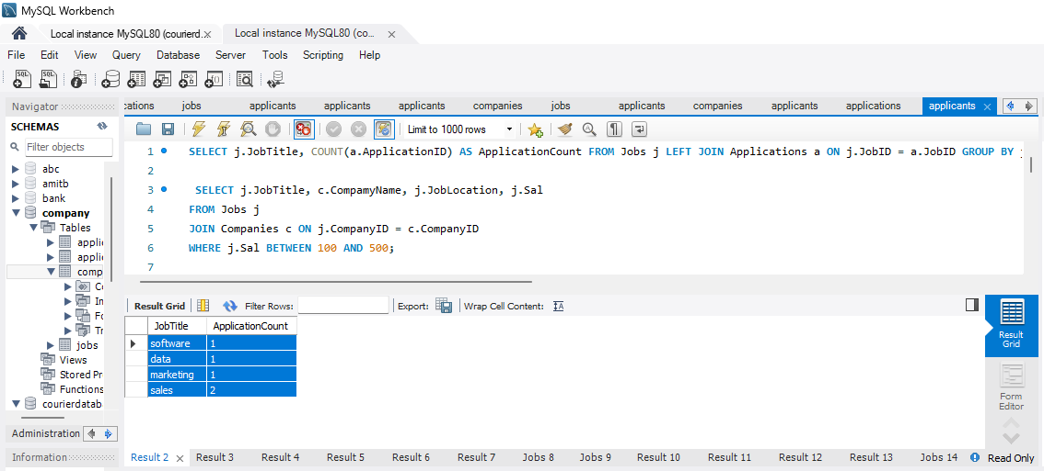

6) SELECT j.JobTitle, c.CompamyName, j.JobLocation, j.Sal

FROM Jobs j

JOIN Companies c ON j.CompanyID = c.CompanyID

WHERE j.Sal BETWEEN 100 AND 500;

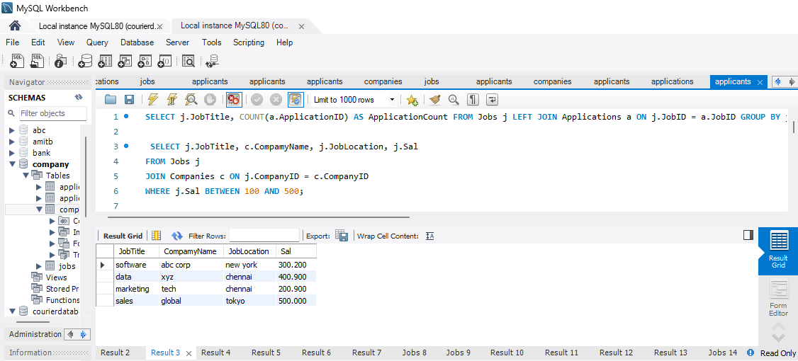

7) SELECT j.JobTitle, c.CompamyName, a.ApplicationDate

FROM Applications a

JOIN Jobs j ON a.JobID = j.JobID

JOIN Companies c ON j.CompanyID = c.CompanyID

WHERE a.ApplicantID = 3;

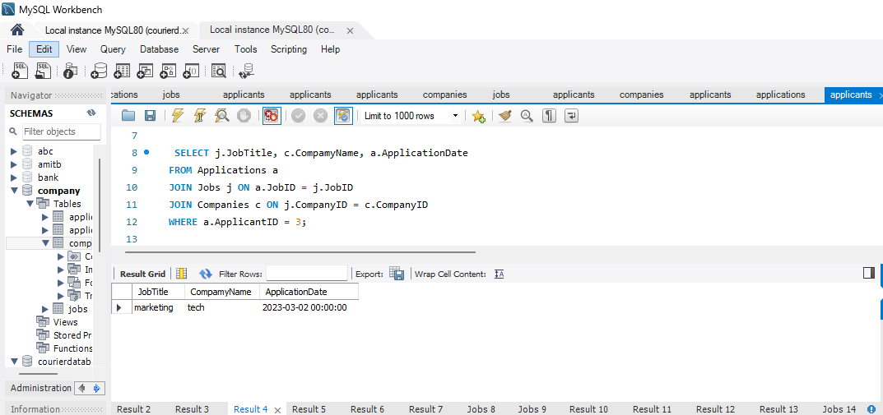

8) SELECT AVG(Sal) AS AverageSalary

FROM Jobs

WHERE Sal > 0;

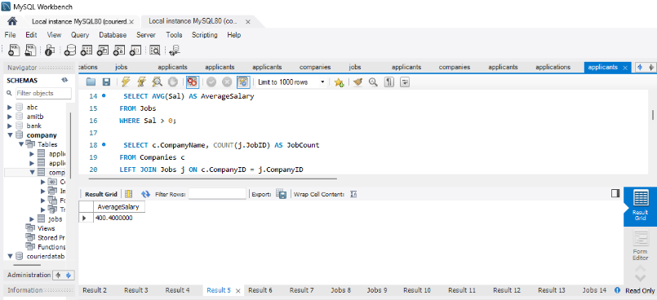

9) SELECT c.CompamyName, COUNT(j.JobID) AS JobCount

FROM Companies c

LEFT JOIN Jobs j ON c.CompanyID = j.CompanyID

GROUP BY c.CompamyName

ORDER BY JobCount DESC;

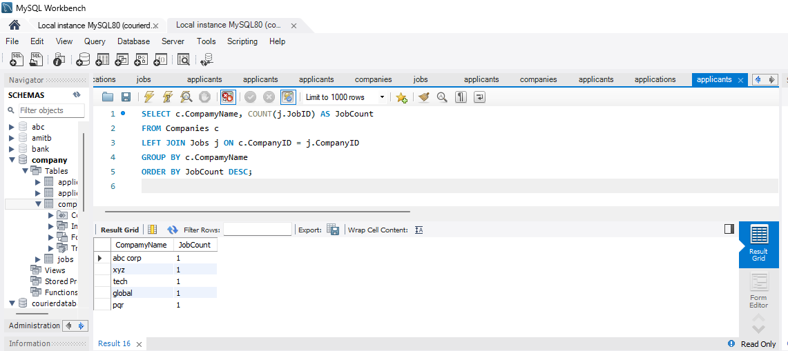

10) select a.applicantid

from applicants a

join applications ap on a.applicantid= ap.applicantid

join jobs j on ap.jobid=j.jobid

join companies c on j.companyid = c.companyid

where c.location like "%C%" and a.experience>=3;

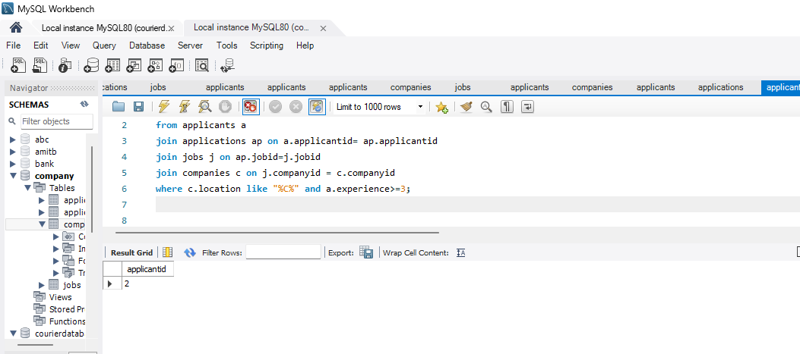

11) SELECT DISTINCT JobTitle

FROM Jobs

WHERE Sal BETWEEN 150.10 AND 450.00;

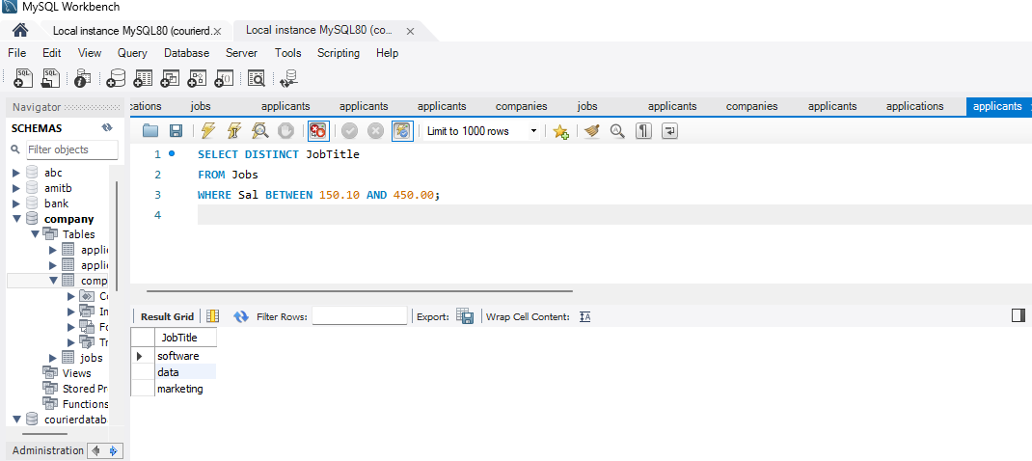

12) SELECT JobID, JobTitle

FROM Jobs

WHERE JobID NOT IN (SELECT DISTINCT JobID FROM Applications);

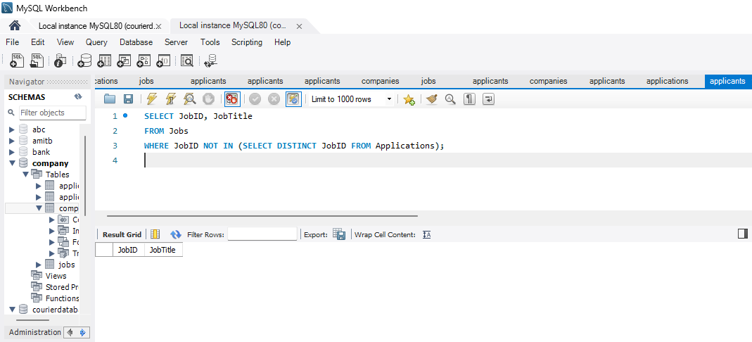

13) SELECT a.FirstName, a.LastName, c.CompamyName, j.JobTitle

FROM Applicants a

JOIN Applications app ON a.ApplicantID = app.ApplicantID

JOIN Jobs j ON app.JobID = j.JobID

JOIN Companies c ON j.CompanyID = c.CompanyID;

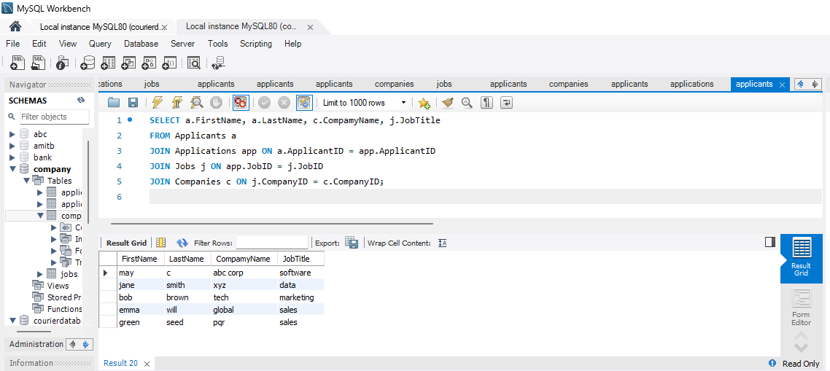

14) SELECT c.CompamyName, COUNT(j.JobID) AS JobCount

FROM Companies c

LEFT JOIN Jobs j ON c.CompanyID = j.CompanyID

GROUP BY c.CompamyName;

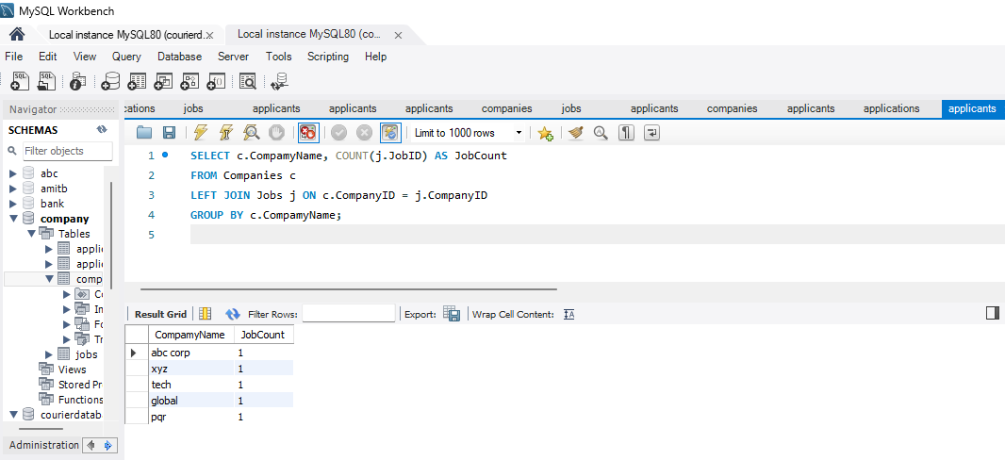

15) SELECT a.FirstName, a.LastName, c.CompamyName, j.JobTitle

FROM Applicants a

cross JOIN Companies c

cross JOIN Jobs j;

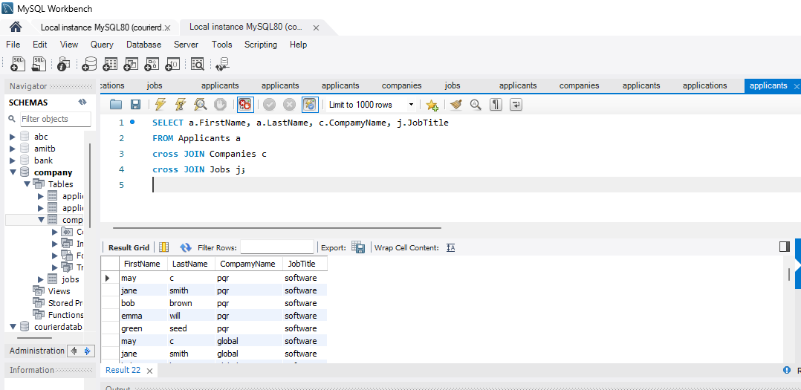

16) SELECT DISTINCT c.CompamyName

FROM Companies c

JOIN Jobs j ON c.CompanyID = j.CompanyID

WHERE j.Sal> (SELECT AVG(Sal) FROM Jobs);

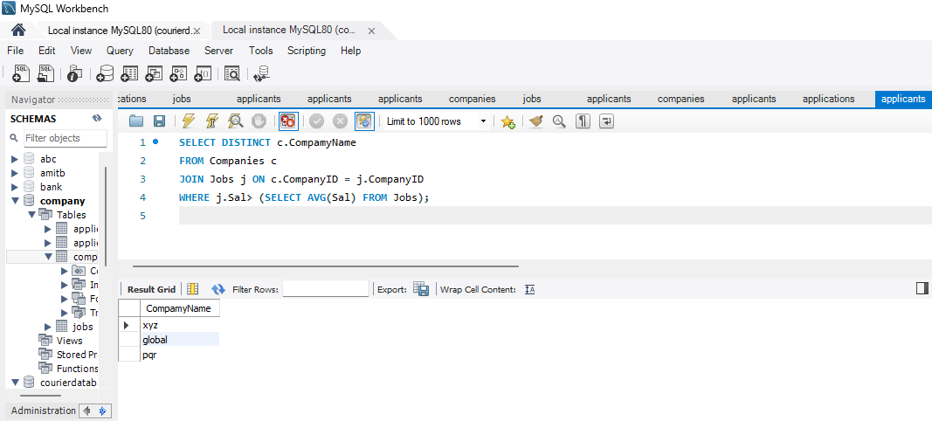

18) SELECT * FROM Jobs WHERE JobTitle LIKE '%Developer%' OR JobTitle LIKE '%Engineer%';

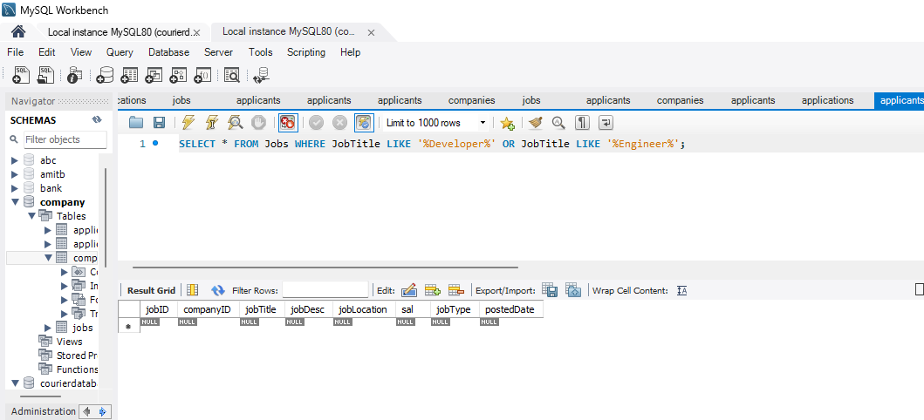

19)SELECT a.FirstName, a.LastName, j.JobTitle

FROM Applicants a

left JOIN Applications app ON a.ApplicantID = app.ApplicantID

left JOIN Jobs j ON app.JobID = j.JobID;

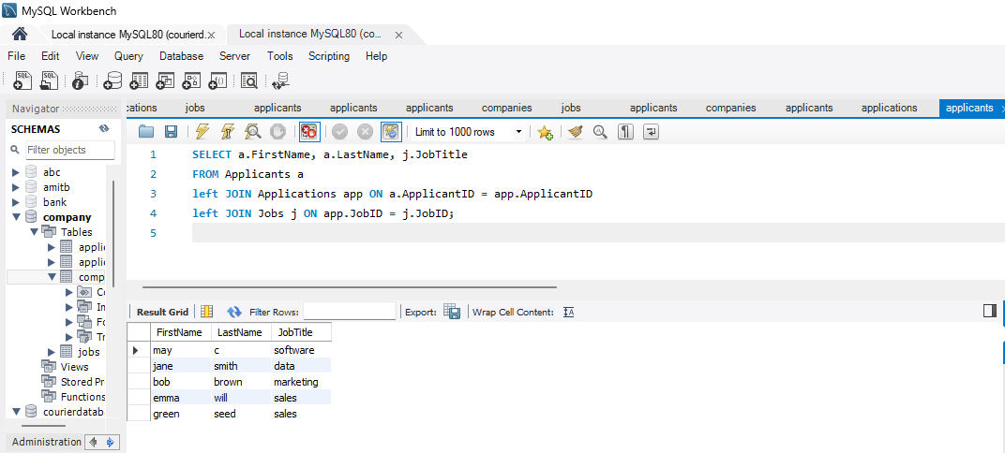

20) SELECT a.firstname,a.lastname , j.jobtitle ,c.compamyname

FROM applicants a join applications ap on a.applicantid=ap.applicantid

JOIN jobs j on ap.jobid=j.jobid

JOIN companies c on c.companyid=j.companyid

WHERE c.location like '%C%' and a.experience >2;

